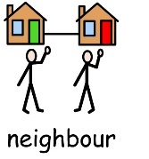
Good neighbour registration form
Are you Happy for us to take your details and hold these securely for the duration of your support with Volunteering?
Yes No
Name:
Email Address:
Telephone number:
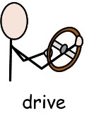
Address:
Do you drive?
Yes, I have my own car
Yes, I have a licence but no vehicle
No, I do not drive
What skills / experience do you have?
I am a carer for family member or friend
I am a professional carer, employed by a care provider
Housekeeping / Gardening
Experience with dogs
Patience
Listening
Compassionate
Organised
What tasks are you willing to support with?
Welfare checks via phone
Collecting prescriptions and getting shopping
Housekeeping or gardening duties
Dog Walking
Do you hold a current DBS?
Yes No
If ‘Yes’ please provide Serial No. or Company name that this was done through…………….
Would you be happy to provide a recent photo of yourself?
Yes No
Are you happy for us to contact individuals in your area?
Yes No

Name:……………………………..
Signed:…………………………….
Date:……………………………………
Once complete return to goodneighbour@thera.co.uk

